**PROJECT DEVELOPMENT PHASE**

**SPRINT-3**

**NODE-RED**

|  |  |
| --- | --- |
| Date | 17 November 2022 |
| Team ID | PNT2022TMID12733 |
| Project Name | IoT Based Safety Gadget for Child Safety Monitoring and Notification |
| Maximum Marks | 1. Marks |

**AIM:**

To connect IBM Watson IoT Platform with Node-red to locate the child and create geofence on it.

**Step 1:**

* Created node-red flow using worldmap, geofence, cloudant, and http request to locate the child.

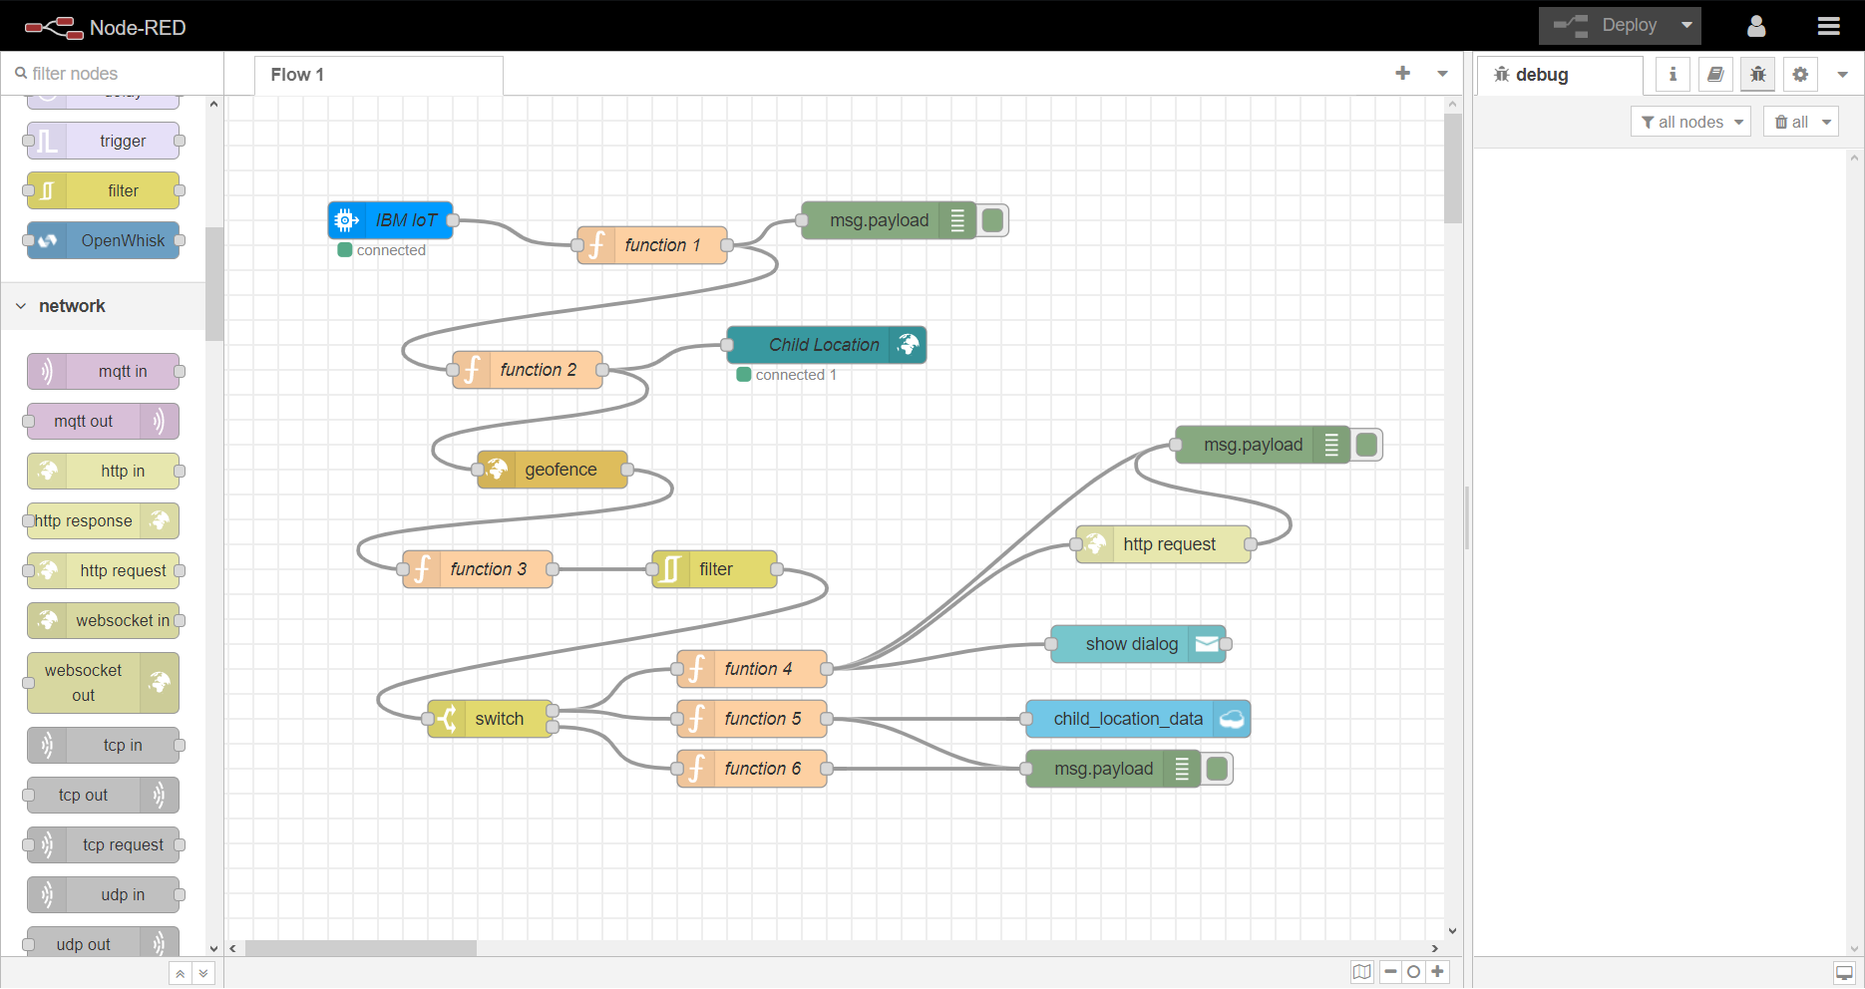

**Step 2:**

* Connected IBM IoT node in node-red to IBM Watson IoT using device credentials.

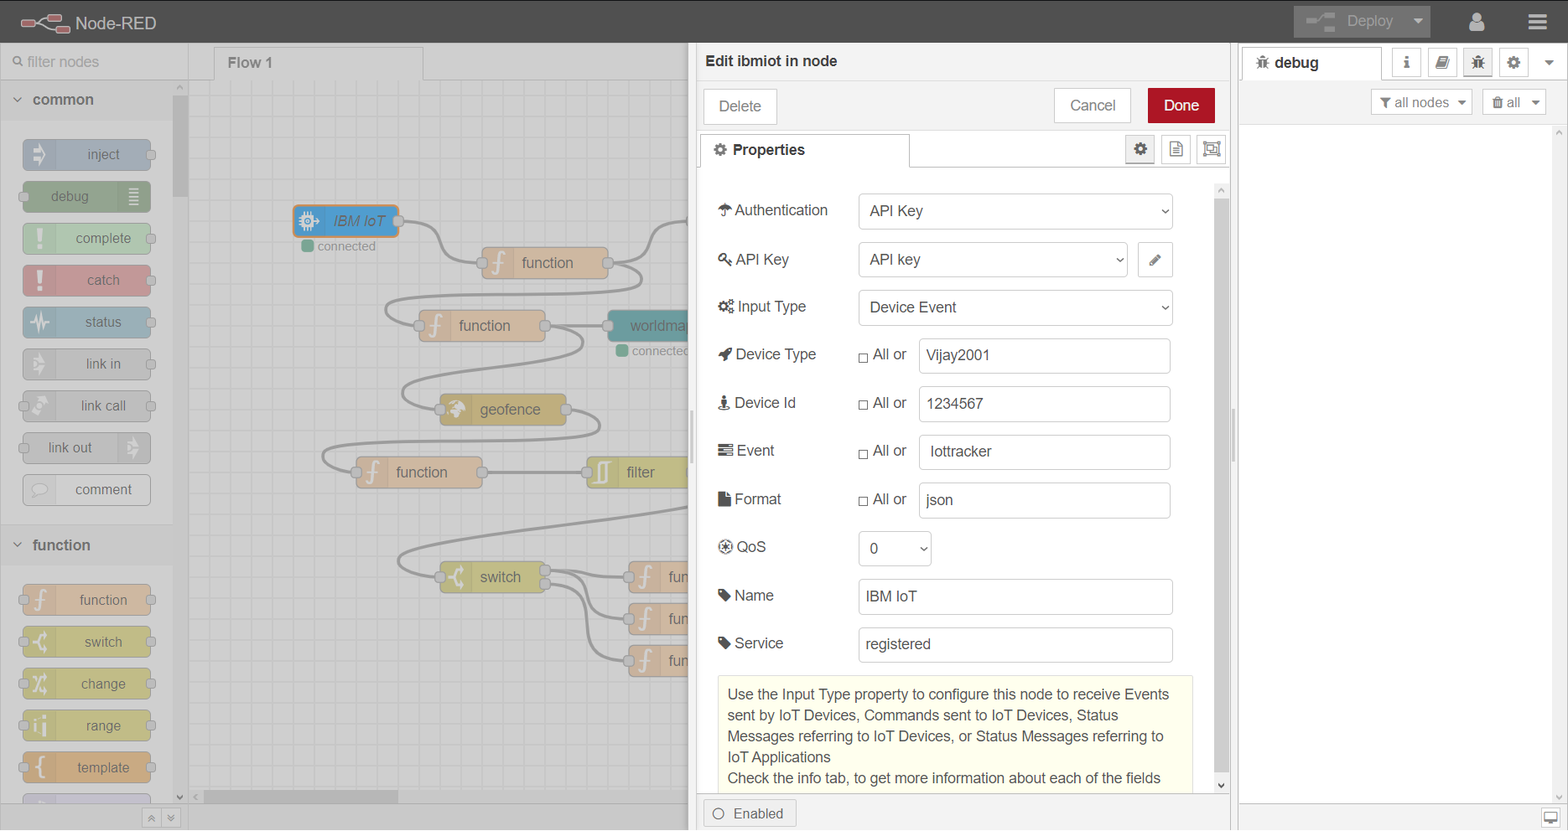

**STEP 3:**

* Created worldmap_ui to show the child location in user interface page of node-red

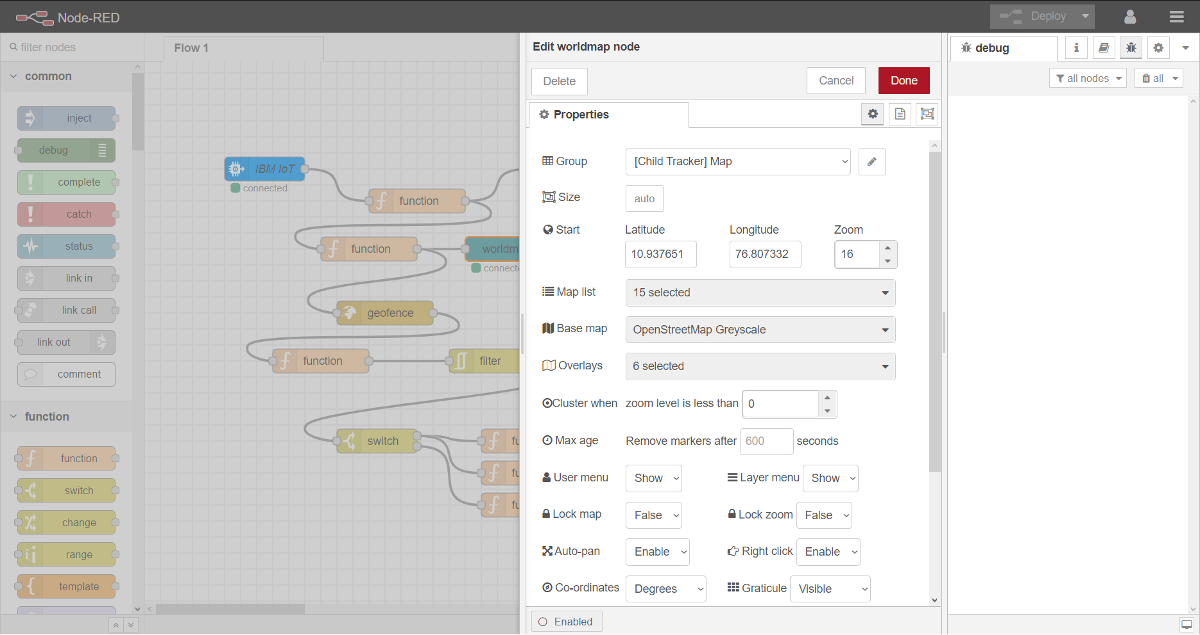

**Step 4:**

* Connected geofence to keep the child safe inside the parent or caretaker’s monitoring

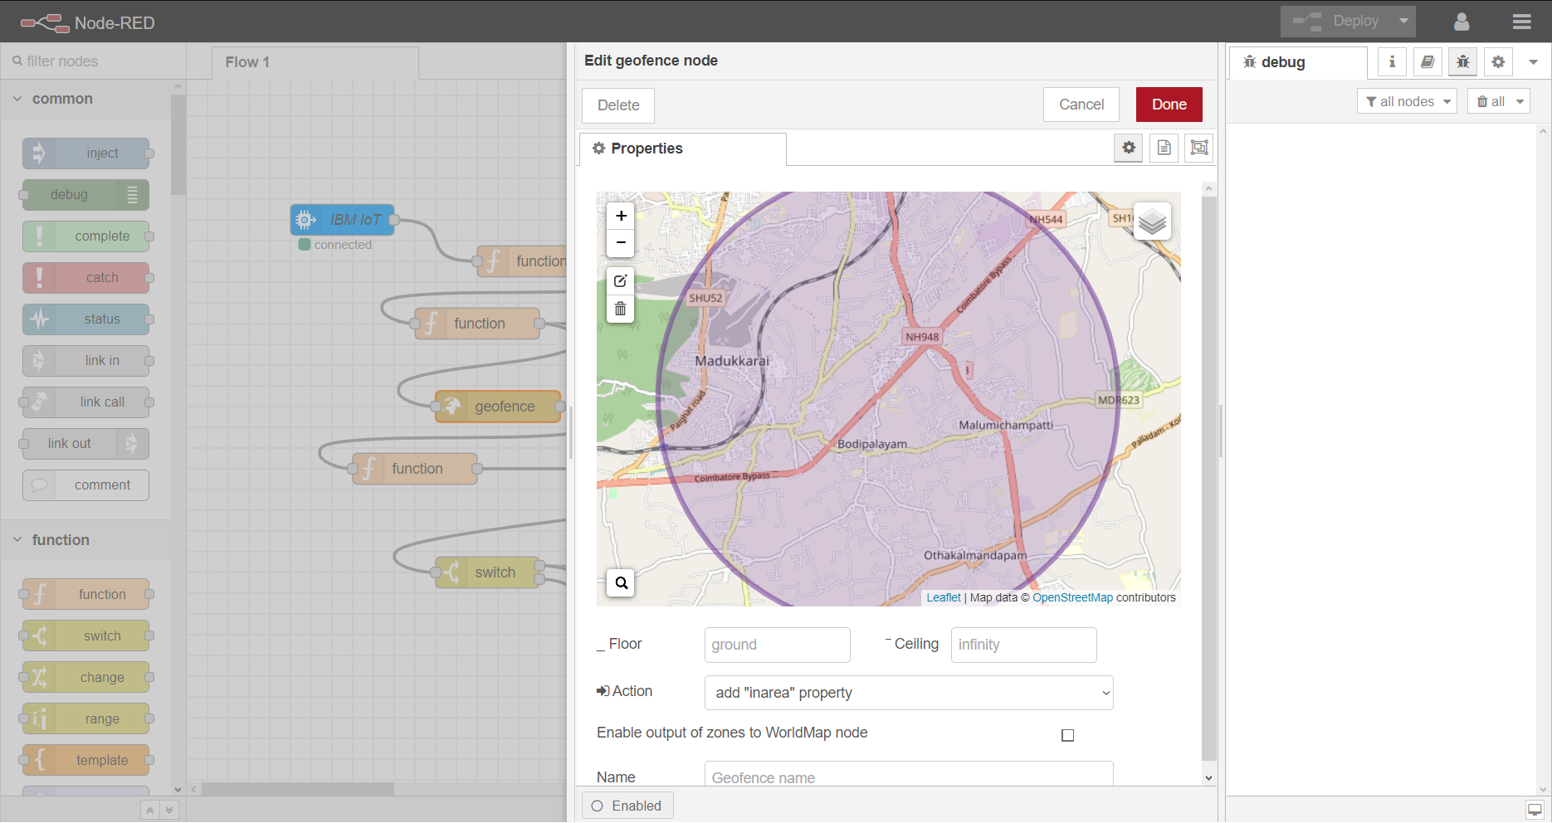

**Step 5:**

* You can see the child location in the ui page of node-red

